**OBJECT ORIENTED PROGRAM**

**PROJECT REPORT**



**TOPIC**

**WEDDING PLANNER**

**SUBMITTED BY:**

PRACHI PAL (LEADER) 1910991549

VANSHIKA ANAND 1910991546

KRITIKA SINGLA 1910991538

ANUBHAV GUPTA 1910991535

GARVIT NANGRU 1910991533

NAVYA CHOPRA 1910991527

**INDEX**

**S.NO TITLE PAGE NO.**

1. ABSTRACT 3.

2. INTRODUCTION 4.

3. WEDDING OVERVIEW 4.

4. SYSTEM MODEL DIAGRAM 5.

5. CODE 8.

6. CONCLUSION 38.

**ABSTRACT**

The wedding planner is a web java application which helps to organize successful wedding events for users . This application provides an easy way to plan their special events. The user can add all the details of the event and can get the service. The user can select the type of event, type of food to be served, type of decoration and estimated budget. All the details given by users will be verified by admin. Admin will add all the details of the planner based on the requirement of the user and send the user’s event details to the planner. The planner will verify and send the response with the confirmation mail. The user needs to complete the payment process to confirm the order.



**INTRODUCTION**

The proposed Wedding Event Planner system provides a smart way to users in booking the venue of the event. The user can book the venue from anywhere and at anytime which saves a lot of time an no other physical effort is required. The wedding planning system designed to be a one step web based platform used by couples , vendors and planners. Each user has different perspective towards the system, depends on the needs in terms of their roles in the system. Couples use the system of their wedding design, plan and management. Planners use the systems to assist in interaction between couples.

THE SERVICE OF A WEDDING PLANNER CAN INCLUDE:

. Identify the needs

. budget preparation

. event design and styling

. planning detailed checklist

. attendee list preparation

. identification of event venue

. identifying and hiring wedding professionals and service providers

**WEDDING OVERVIEW**

A wedding is the ceremony where people are united in marriage. Wedding traditions and customs vary greatly between cultures , ethnic groups, religions, countries and social classes. Most wedding ceremonies involve an exchange of wedding views by the couple ,presentation of a gift, symbolic item, flowers ,and a public proclamation of marriage by an authority figure or leader. Special wedding garments are often worn and the ceremony is sometimes followed by a wedding reception. Music, poetry, prayers and readings from religious texts or literature are also commonly incorporated into the ceremony.

Individuals may marry for several reasons, including legal, social, libidinal, emotional, financial, spiritual and religious purposes. Who they marry maybe influenced by socially determined rules, prescriptive marriage rules, parental choice and individual desire.

**SYSTEM MODEL DIAGRAM**

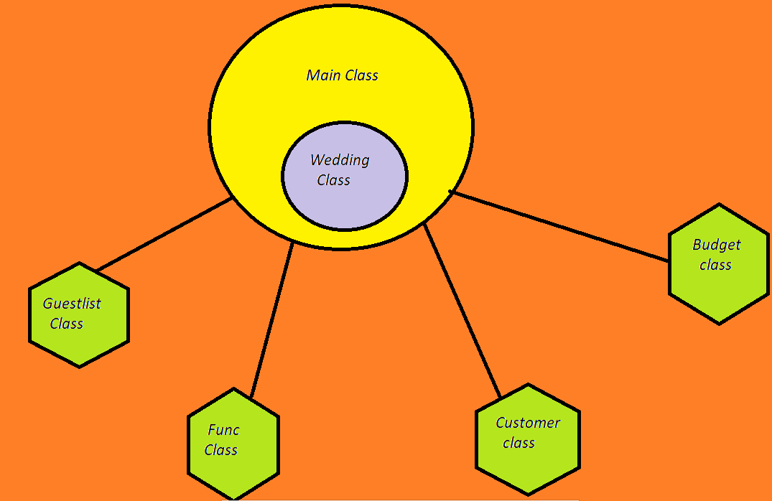

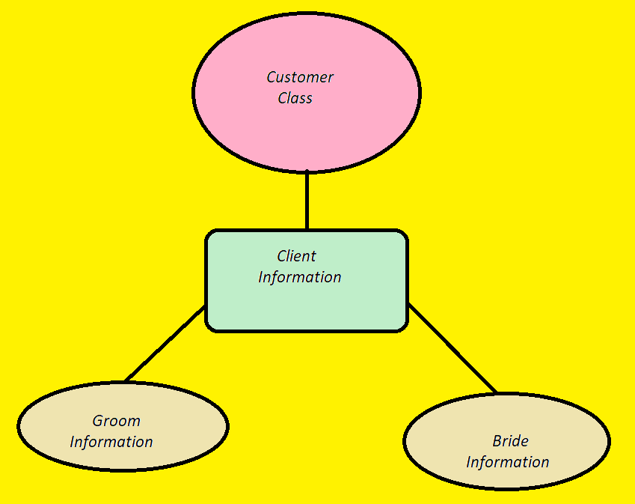

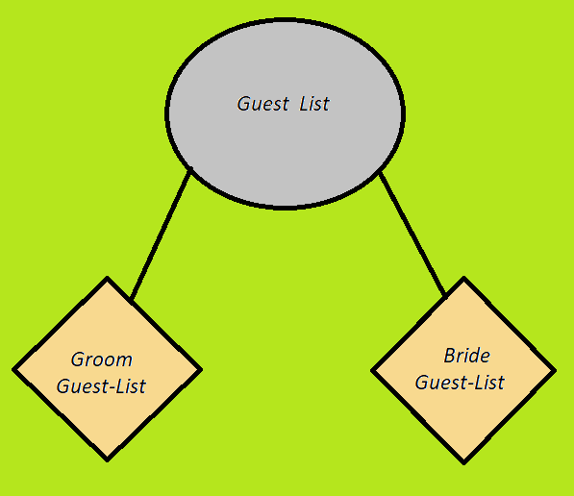

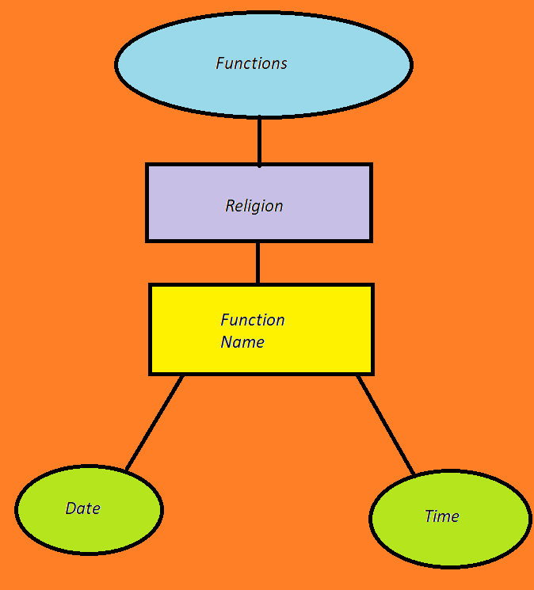

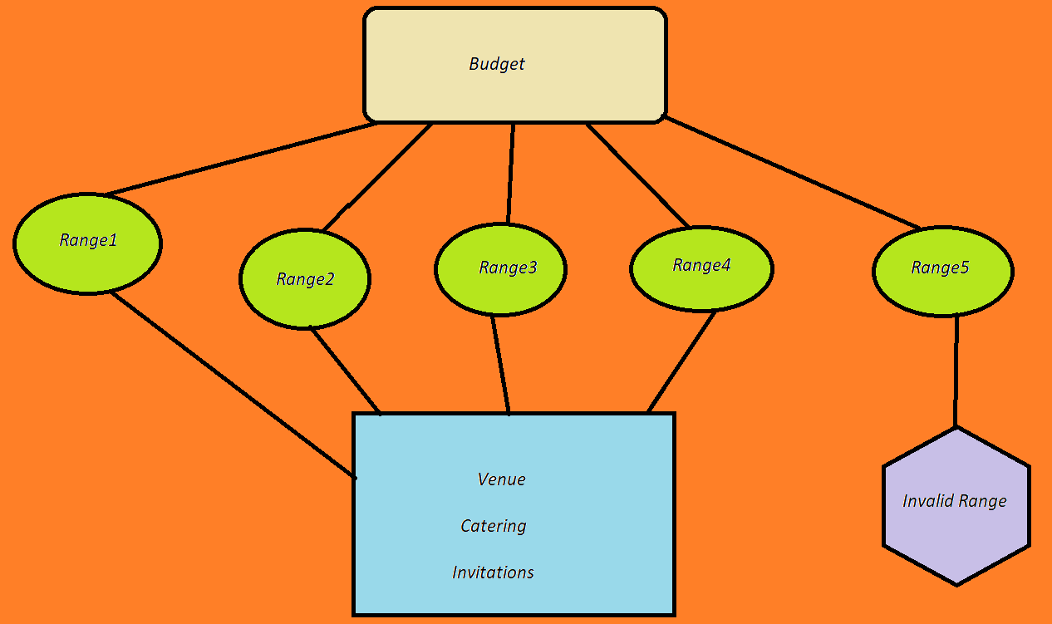

**CODE**

**MAIN CLASS :**

import java.util.Scanner;

public class Main

{

public static void main(String[] args)

{

System.out.println("Hi,welcome to ..... wedding planner. ");

System.out.println("1) Please enter A to fill personal information and to view to personal information filled by you");

System.out.println("2) Please enter F to checkout the functions according to your religion");

System.out.println("3) Please enter B to check the range of the budget ");

System.out.println("4) Please enter G to check or add guest ");

System.out.println("Type E when you want to exit!");

wedding w = new wedding();

w.choices();

}

}

class wedding{

void choices()

{

char CHOICE='\0';

do{

Scanner scanner = new Scanner(System.in);

CHOICE = scanner.next().charAt(0);

switch(CHOICE)

{

case 'A':

System.out.println("--------------------------------------------------");

Customer c = new Customer();

c.personalinfo();

System.out.println("1) Please enter A to fill personal information and to view to personal information filled by you");

System.out.println("2) Please enter F to checkout the functions according to your religion");

System.out.println("3) Please enter B to check the range of the budget ");

System.out.println("4) Please enter G to check or add guest ");

System.out.println("Type E when you want to exit!");

System.out.println("---------------------------------------------------");

break;

case 'a':

System.out.println("--------------------------------------------------");

Customer c1 = new Customer();

c1.personalinfo();

System.out.println("1) Please enter A to fill personal information and to view to personal information filled by you");

System.out.println("2) Please enter F to checkout the functions according to your religion");

System.out.println("3) Please enter B to check the range of the budget ");

System.out.println("4) Please enter G to check or add guest ");

System.out.println("Type E when you want to exit!");

System.out.println("---------------------------------------------------");

break;

case 'B':

System.out.println("--------------------------------------------------");

Budget b = new Budget();

b.methodbudget();

System.out.println("1) Please enter A to fill personal information and to view to personal information filled by you");

System.out.println("2) Please enter F to checkout the functions according to your religion");

System.out.println("3) Please enter B to check the range of the budget ");

System.out.println("4) Please enter G to check or add guest ");

System.out.println("Type E when you want to exit!");

System.out.println("---------------------------------------------------");

break;

case 'b':

System.out.println("--------------------------------------------------");

Budget b1 = new Budget();

b1.methodbudget();

System.out.println("1) Please enter A to fill personal information and to view to personal information filled by you");

System.out.println("2) Please enter F to checkout the functions according to your religion");

System.out.println("3) Please enter B to check the range of the budget ");

System.out.println("4) Please enter G to check or add guest ");

System.out.println("Type E when you want to exit!");

System.out.println("---------------------------------------------------");

break;

case 'F':

System.out.println("--------------------------------------------------");

Func f = new Func();

f.info();

System.out.println("1) Please enter A to fill personal information and to view personal information filled by you");

System.out.println("2) Please enter F to checkout the functions according to your religion");

System.out.println("3) Please enter B to check the range of the budget ");

System.out.println("4) Please enter G to check or add guest ");

System.out.println("Type E when you want to exit!");

System.out.println("---------------------------------------------------");

break;

case 'f':

System.out.println("--------------------------------------------------");

Func f1 = new Func();

f1.info();

System.out.println("1) Please enter A to fill personal information and to view personal information filled by you");

System.out.println("2) Please enter F to checkout the functions according to your religion");

System.out.println("3) Please enter B to check the range of the budget ");

System.out.println("4) Please enter G to check or add guest ");

System.out.println("Type E when you want to exit!");

System.out.println("---------------------------------------------------");

break;

case 'g':

System.out.println("--------------------------------------------------");

Guestlist g = new Guestlist();

g.methodguest();

System.out.println("1) Please enter A to fill personal information and to view personal information filled by you");

System.out.println("2) Please enter F to checkout the functions according to your religion");

System.out.println("3) Please enter B to check the range of the budget ");

System.out.println("4) Please enter G to check or add guest ");

System.out.println("Type E when you want to exit!");

System.out.println("---------------------------------------------------");

break;

case 'G':

System.out.println("--------------------------------------------------");

Guestlist g1= new Guestlist();

g1.methodguest();

System.out.println("1) Please enter A to fill personal information and to view personal information filled by you");

System.out.println("2) Please enter F to checkout the functions according to your religion");

System.out.println("3) Please enter B to check the range of the budget ");

System.out.println("4) Please enter G to check or add guest ");

System.out.println("Type E when you want to exit!");

System.out.println("---------------------------------------------------");

break;

case 'E':

System.out.println("---------------------------------------------------");

break;

case 'e':

System.out.println("---------------------------------------------------");

break;

default:

System.out.println("Invalid Option!! Please enter again");

break;

}

}

while(CHOICE != 'E');

System.out.println("ThankYou for using our services!");

System.out.println("**");

}

}

**CUSTOMER:**

import java.util.Scanner;

public class Customer

{

public void personalinfo()

{

char CHOICE2='\0';

System.out.println("Please enter your name");

Scanner namecustomer = new Scanner(System.in);

String NAMECUSTOMER = namecustomer.next();

System.out.println("Hi "+NAMECUSTOMER );

System.out.println("Enter your relation with Groom (Enter none if you are from Bride side): ");

Scanner relationgroom = new Scanner(System.in);

String RELATIONGROOM = relationgroom.next();

System.out.println("Enter your relation with Bride (Enter none if you are from Groom side): ");

Scanner relationbride = new Scanner(System.in);

String RELATIONBRIDE = relationbride.next();

System.out.println("Please enter the name of Groom: ");

Scanner groom = new Scanner(System.in);

String GROOM = groom.next();

System.out.println("Please enter the name of Bride: ");

Scanner bride = new Scanner(System.in);

String BRIDE = bride.next();

System.out.println("Please enter phone number from Groom Side : ");

Scanner groomphone = new Scanner(System.in);

long GROOMPHONE = groomphone.nextLong();

System.out.println("Please enter phone number from Bride Side : ");

Scanner bridephone = new Scanner(System.in);

long BRIDEPHONE = bridephone.nextLong();

System.out.println("Please enter address of Groom : ");

Scanner groomaddress = new Scanner(System.in);

String GROOMADDRESS = groomaddress.next();

System.out.println("Please also enter the pin-code : ");

Scanner groompincode = new Scanner(System.in);

int GROOMPINCODE = groompincode.nextInt();

System.out.println("Please enter address of Bride : ");

Scanner brideaddress = new Scanner(System.in);

String BRIDEADDRESS = brideaddress.next();

System.out.println("Please also enter the pin-code : ");

Scanner bridepincode = new Scanner(System.in);

int BRIDEPINCODE = bridepincode.nextInt();

System.out.println("Please enter email-id of Groom : ");

Scanner groomemail = new Scanner(System.in);

String GROOMEMAIL = groomemail.next();

System.out.println("Please enter email-id of Bride : ");

Scanner brideemail = new Scanner(System.in);

String BRIDEEMAIL = brideemail.next();

System.out.println("Enter 'a' if you want to check the personal information filled by you else tybe 'b'");

Scanner choice2 = new Scanner(System.in);

CHOICE2 = choice2.next().charAt(0);

System.out.println("a is "+CHOICE2);

if(CHOICE2==97|| CHOICE2==65)

{

System.out.println();

System.out.println();

System.out.println("Client name : "+ NAMECUSTOMER);

System.out.println("Your relation with Groom : "+ RELATIONGROOM);

System.out.println("Your relation with Bride : "+ RELATIONBRIDE);

System.out.println("Name of Groom: "+ GROOM);

System.out.println("Name of Bride: "+ BRIDE);

System.out.println("Contact number from Groom side: "+ GROOMPHONE );

System.out.println("Contact number from Bride side: "+ BRIDEPHONE );

System.out.println("Groom address (including pin-code): " + GROOMADDRESS + "(" + GROOMPINCODE + ")");

System.out.println("Bride address (including pin-code): " + BRIDEADDRESS + "(" + BRIDEPINCODE + ")");

System.out.println("Groom email-id: " + GROOMEMAIL );

System.out.println("Bride email-id: " + BRIDEEMAIL );

}

}

}

**Guest-list:**

class groom

{

String name;

String address;

groom(String name,String address)

{

this.name = name;

this.address =address;

}

}

class bride

{

String n;

String add;

bride(String n,String add)

{

this.n = n;

this.add = add;

}

}

public class Guestlist

{

public void methodguest()

{

groom[] arr;

arr = new groom[40];

arr[0] = new groom("Kartik","Jaipur");

arr[1] = new groom("Vaibhav","Jalandhar");

arr[2] = new groom("Shikar","Zirakpur");

arr[3] = new groom("Dharmesh","Solan");

arr[4] = new groom("Mohit","Dera Bassi");

arr[5] = new groom("Preeti","Shimla");

arr[6] = new groom("Sania","Zirakpur");

arr[7] = new groom("Sonal","Gujarat");

arr[8] = new groom("Aditi","Jind");

arr[9] = new groom("Siya","Patiala");

arr[10] = new groom("Vihaan","Kanpur");

arr[11] = new groom("Mohammed","Ghaziabad");

arr[12] = new groom("Aarav","Meerut");

arr[13] = new groom("Ishaan","Varanasi");

arr[14] = new groom("Dhruv","Aligarh");

arr[15] = new groom("Shaurya","Agra");

arr[16] = new groom("Ananya","Sangrur");

arr[17] = new groom("Sambhav","Jalandhar");

arr[18] = new groom("Charu","Gurdaspur");

arr[19] = new groom("Bhumika","Muktsar");

arr[20] = new groom("Raghav","Moga");

arr[21] = new groom("Sourav","Bathinda");

arr[22] = new groom("Nandini","Abohar");

arr[23] = new groom("Shifali","Mohali");

arr[24] = new groom("Chetan","Malerkotla");

arr[25] = new groom("Advik","Khanna");

arr[26] = new groom("Aarushi","Barnala");

arr[27] = new groom("Teena","Firozpur");

arr[28] = new groom("Aryan","Kapurthala");

arr[29] = new groom("Simran","Fazilka");

arr[30] = new groom("Kartik","Pathankot");

arr[31] = new groom("Abhishek","Batala");

arr[32] = new groom("Suhab","Amritsar");

arr[33] = new groom("Rashmeet","Rajpura");

arr[34] = new groom("Taran","Sunam");

arr[35] = new groom("Sonal","Ludhiana");

arr[36] = new groom("Kabir","Noida");

arr[37] = new groom("Atharv","Jhansi");

arr[38] = new groom("Raman","Gorakhpur");

arr[39] = new groom("Harpreet","Delhi");

bride[] a;

a = new bride[40];

a[0] = new bride("Aarti","Ludhiana");

a[1] = new bride("Vaibhav","Delhi");

a[2] = new bride("Shikhar","Zirakpur");

a[3] = new bride("Deepankar","Solan");

a[4] = new bride("Mohit","Dera Bassi");

a[5] = new bride("Preeti","Shimla");

a[6] = new bride("Pragati","Zirakpur");

a[7] = new bride("Sonali","Pune");

a[8] = new bride("Aditi","Jind");

a[9] = new bride("Siya","Patiala");

a[10] = new bride("Tejas","Nagpur");

a[11] = new bride("Abeer","Lucknow");

a[12] = new bride("Samarth","Jaipur");

a[13] = new bride("Darsh","Surat");

a[14] = new bride("Yash","Faridabad");

a[15] = new bride("Samar","Bhopal");

a[16] = new bride("Abdul","Rajkot");

a[17] = new bride("Avneet","Pune");

a[18] = new bride("Jashan","Hyderabad");

a[19] = new bride("Devansh","Kolkata");

a[20] = new bride("Pratyush","Kochi");

a[21] = new bride("Rohan","Patna");

a[22] = new bride("Varun","Indore");

a[23] = new bride("Neel","Dehradun");

a[24] = new bride("Gautam","Jodhpur");

a[25] = new bride("Manan","Udaipur");

a[26] = new bride("Kunal","Ghaziabad");

a[27] = new bride("Sarthak","Kanpur");

a[28] = new bride("Vivaan","Ranchi");

a[29] = new bride("Ankur","Guwahati");

a[30] = new bride("Tarun","Patiala");

a[31] = new bride("Samendra","Chandigarh");

a[32] = new bride("Javed","Bhopal");

a[33] = new bride("Ansh","Saharanpur");

a[34] = new bride("Aditya","Firozabad");

a[35] = new bride("Arpita","Gurugram");

a[36] = new bride("Anu","Bareilley");

a[37] = new bride("Karan","Ayodhya");

a[38] = new bride("Harsh","Amritsar");

a[39] = new bride("Jain","Jaipur");

int j=1;

System.out.println("Groom side:");

for (int i = 0; i < arr.length; i++)

{

System.out.print(j+"\tName : " + arr[i].name+"\n");

System.out.println("\tAddress : "+arr[i].address);

System.out.println();

j++;

}

System.out.println("\n\n\n");

System.out.println("Bride side:");

int x=1;

for (int k = 0; k < a.length; k++)

{

System.out.print(x+"\tName : " + arr[k].name+"\n");

System.out.println("\tAddress : "+arr[k].address);

System.out.println();

x++;

}

}

}

**Functions:**

import java.util.Scanner;

public class Func

{

public void info()

{

int FUNCTIONCOUNT;

int DATE;

int MONTH;

int YEAR;

int HOURS;

int MIN;

System.out.println("\n\nPlease enter further details for functions and dates of functions");

System.out.println("\nPlease enter your religion and related functions");

Scanner religion = new Scanner(System.in);

String RELIGION = religion.next();

System.out.println(RELIGION);

if(RELIGION.equals("hindu")||RELIGION.equals("Hindu"))

{

System.out.println("Functions in hindu religion are:");

System.out.println("1.\tRoka Ceremony\n2.\tEngagement Ceremony\n3.\tSangeet Ceremony\n4.\tWedding\n\n");

System.out.println("\nPlease enter how many functions you want!");

Scanner functioncount = new Scanner(System.in);

FUNCTIONCOUNT= functioncount.nextInt();

System.out.println("Please enter names of functions you want.");

Scanner namesoffunctions = new Scanner(System.in);

String[] NAMESOFFUNCTIONS= new String[FUNCTIONCOUNT];

Scanner date=new Scanner(System.in);

Scanner month=new Scanner(System.in);

Scanner year=new Scanner(System.in);

Scanner hours=new Scanner(System.in);

Scanner min=new Scanner(System.in);

for(int i=0;i<FUNCTIONCOUNT;i++)

{

System.out.println("enter name of "+(i+1)+" function");

NAMESOFFUNCTIONS[i] = namesoffunctions.nextLine();

System.out.println("Enter date of " + NAMESOFFUNCTIONS[i]+" Ceremony");

System.out.println("Date:");

DATE=date.nextInt();

System.out.println("Month:");

MONTH=month.nextInt();

System.out.println("Year:");

YEAR=year.nextInt();

System.out.println("Enter time of the Ceremony(for eg: 23 hours 27 mins i.e complete clock)");

System.out.println("Hours:");

HOURS=hours.nextInt();

System.out.println("Minutes:");

MIN=min.nextInt();

}

}

else if(RELIGION.equals("muslim")||RELIGION.equals("Muslim"))

{

System.out.println("Functions in muslim religion are:");

System.out.println("1.\tMngni\n2.\tManjha\n3.\tMehendi\n4.\tBaraat\n5.\tNikah\n");

System.out.println("Please enter how many functions you want!");

Scanner functioncount = new Scanner(System.in);

FUNCTIONCOUNT= functioncount.nextInt();

System.out.println("Please enter names of functions you want.");

Scanner namesoffunctions = new Scanner(System.in);

String[] NAMESOFFUNCTIONS= new String[FUNCTIONCOUNT];

Scanner date=new Scanner(System.in);

Scanner month=new Scanner(System.in);

Scanner year=new Scanner(System.in);

Scanner hours=new Scanner(System.in);

Scanner min=new Scanner(System.in);

for(int i=0;i<FUNCTIONCOUNT;i++)

{

System.out.println("enter name of "+(i+1)+" function");

NAMESOFFUNCTIONS[i] = namesoffunctions.nextLine();

System.out.println("enter date of " + NAMESOFFUNCTIONS[i]);

System.out.println("Date:");

DATE=date.nextInt();

System.out.println("Month:");

MONTH=month.nextInt();

System.out.println("Year:");

YEAR=year.nextInt();

System.out.println("Enter time of the Ceremony(for eg: 23 hours 27 mins i.e complete clock)");

System.out.println("Hours:");

HOURS=hours.nextInt();

System.out.println("Minutes:");

MIN=min.nextInt();

}

}

else if(RELIGION.equals("parsi")||RELIGION.equals("Parsi"))

{

System.out.println("Functions in parsi religion are:");

System.out.println("1.\tMadhavsaro\n2.\tRupia Peravanu\n3.Wedding\n\n");

System.out.println("Please enter how many functions you want!");

Scanner functioncount = new Scanner(System.in);

FUNCTIONCOUNT= functioncount.nextInt();

System.out.println("Please enter names of functions you want.");

Scanner namesoffunctions = new Scanner(System.in);

String[] NAMESOFFUNCTIONS= new String[FUNCTIONCOUNT];

Scanner date=new Scanner(System.in);

Scanner month=new Scanner(System.in);

Scanner year=new Scanner(System.in);

Scanner hours=new Scanner(System.in);

Scanner min=new Scanner(System.in);

for(int i=0;i<FUNCTIONCOUNT;i++)

{

System.out.println("enter name of "+(i+1)+" function");

NAMESOFFUNCTIONS[i] = namesoffunctions.nextLine();

System.out.println("enter date of " + NAMESOFFUNCTIONS[i]);

System.out.println("Date:");

DATE=date.nextInt();

System.out.println("Month:");

MONTH=month.nextInt();

System.out.println("Year:");

YEAR=year.nextInt();

System.out.println("Enter time of the Ceremony(for eg: 23 hours 27 mins i.e complete clock)");

System.out.println("Hours:");

HOURS=hours.nextInt();

System.out.println("Minutes:");

MIN=min.nextInt();

}

}

else if(RELIGION.equals("christian")||RELIGION.equals("Christian"))

{

System.out.println("Functions in christian religion are:");

System.out.println("1.\tRoce Ceremony\n2.\tBachelor Party\n3.\tBridal Shower\n4.\tWedding\n\n");

System.out.println("Please enter how many functions you want!");

Scanner functioncount = new Scanner(System.in);

FUNCTIONCOUNT= functioncount.nextInt();

System.out.println("Please enter names of functions you want.");

Scanner namesoffunctions = new Scanner(System.in);

String[] NAMESOFFUNCTIONS= new String[FUNCTIONCOUNT];

Scanner date=new Scanner(System.in);

Scanner month=new Scanner(System.in);

Scanner year=new Scanner(System.in);

Scanner hours=new Scanner(System.in);

Scanner min=new Scanner(System.in);

for(int i=0;i<FUNCTIONCOUNT;i++)

{

System.out.println("enter name of "+(i+1)+" function");

NAMESOFFUNCTIONS[i] = namesoffunctions.nextLine();

System.out.println("enter date of " + NAMESOFFUNCTIONS[i]);

System.out.println("Date:");

DATE=date.nextInt();

System.out.println("Month:");

MONTH=month.nextInt();

System.out.println("Year:");

YEAR=year.nextInt();

System.out.println("Enter time of the Ceremony(for eg: 23 hours 27 mins i.e complete clock)");

System.out.println("Hours:");

HOURS=hours.nextInt();

System.out.println("Minutes:");

MIN=min.nextInt();

}

}

else if(RELIGION.equals("Sikh")||RELIGION.equals("Sikh"))

{

System.out.println("Functions in sikh religion are:");

System.out.println("1.\tRokka\n2.\tKurmai\n3.\tDholki\n4.\tMehndi\n5.\tWedding\n");

System.out.println("Please enter how many functions you want!");

Scanner functioncount = new Scanner(System.in);

FUNCTIONCOUNT= functioncount.nextInt();

System.out.println("Please enter names of functions you want.");

Scanner namesoffunctions = new Scanner(System.in);

String[] NAMESOFFUNCTIONS= new String[FUNCTIONCOUNT];

Scanner date=new Scanner(System.in);

Scanner month=new Scanner(System.in);

Scanner year=new Scanner(System.in);

Scanner hours=new Scanner(System.in);

Scanner min=new Scanner(System.in);

for(int i=0;i<FUNCTIONCOUNT;i++)

{

System.out.println("enter name of "+(i+1)+" function");

NAMESOFFUNCTIONS[i] = namesoffunctions.nextLine();

System.out.println("enter date of " + NAMESOFFUNCTIONS[i]);

System.out.println("Date:");

DATE=date.nextInt();

System.out.println("Month:");

MONTH=month.nextInt();

System.out.println("Year:");

YEAR=year.nextInt();

System.out.println("Enter time of the Ceremony(for eg: 23 hours 27 mins i.e complete clock)");

System.out.println("Hours:");

HOURS=hours.nextInt();

System.out.println("Minutes:");

MIN=min.nextInt();

}

}

else

{

System.out.println("Sorry!! we don't know much about this religion");

}

}

}

**BUDGET:**

import java.util.Scanner;

public class Budget

{

public void methodbudget()

{

System.out.println("Enter your budget range and it should not be less than 5");

wed w = new wed();

w.amounts();

}

}

class wed

{

void amounts()

{

int CHOICE5 =0;

int CHOICE6=0;

if(CHOICE6 == 0);

{

Scanner scanner = new Scanner(System.in);

CHOICE5 = scanner.nextInt();

if(CHOICE5==0 || CHOICE5<=4)

{

System.out.println("Invalid budget range") ;

}

else if(CHOICE5 > 5 && CHOICE5 <=10)

{

bud bd = new bud();

bd.range();

}

else if(CHOICE5 >10 && CHOICE5 <=15)

{

bud b1 = new bud();

b1.range2();

}

else if(CHOICE5 > 15 && CHOICE5 <=20)

{

bud b2 = new bud();

b2.range3();

}

else

{

bud b3 = new bud();

b3.range4();

}

}

}

}

class bud

{

void range()

{

System.out.println("Caterers under this budget range are:\n1)\tJoshi Caterers(350/Person)\n2)\tBrar Caterers(500/Person)\n3)\tCreative ChefCaterers(450/Person)\n4)\tHotel Mountview(600/Person)");

System.out.println("\nselect the caterers you want:");

Scanner s = new Scanner(System.in);

String cater = s.next();

System.out.println("\nVenues under this budget range are:\n1)\tVirasat Villa\n2)\tOrchid Farms\n3)\tHotel Amar\n4)\tJaggi Resorts");

System.out.println("\nSPECIAL DECORATION OF:\nWhite Flowers and Curtain String Light");

System.out.println("\nselect the venue you want:");

Scanner c = new Scanner(System.in);

String ven = c.next();

System.out.println("\nInvitation card maker under this budget range are:\n1)\tThe Pink Umbrella\n2)\tShri Ganesh Graphics\n3)\tTaj Printers\n4)\tSajawat");

System.out.println("\nselect the invitation card maker you want:");

Scanner i = new Scanner(System.in);

String inv = i.next();

System.out.println("---------------------------------------------------");

}

void range2()

{

System.out.println("Caterers under this budget range are:\n1)\tAone Caterers(800/Person)\n2)\tBatra Caterers(900/Person)\n3)\tAura Events and Caterers(850/Person)\n4)\tVivaah Orchid Catering(800/Person)");

System.out.println("\nselect the caterers you want:");

Scanner s = new Scanner(System.in);

String cater = s.next();

System.out.println("\nVenues under this budget range are:\n1)\tHotel ALG International\n2)\tThe Gaur\n3)\tDream Palm Resort\n4)\tAura Garden");

System.out.println("\nSPECIAL DECORATION OF:\nRed Flowers, Table Pearle and Flower Market Bucket");

System.out.println("\nselect the venue you want:");

Scanner c = new Scanner(System.in);

String ven = c.next();

System.out.println("\nInvitation card maker under this budget range are:\n1)\tNimantran Wedding Card\n2)\tNaina Graphics\n3)\tVerma Siyaahi\n4)\tEssence Invitations");

System.out.println("\nselect the invitation card maker you want:");

Scanner i = new Scanner(System.in);

String inv = i.next();

System.out.println("---------------------------------------------------");

}

void range3()

{

System.out.println("Caterers under this budget range are:\n1)\tCuisine Express(1000/Person)\n2)\tChefs and Cuisine Catering(1300/Person)\n3)\tArista Catering(1000/Person)\n4)\tCater to Cater(1500/Person)");

System.out.println("\nselect the caterers you want:");

Scanner s = new Scanner(System.in);

String cater = s.next();

System.out.println("\nVenues under this budget range are:\n1)\tArista Palace\n2)\tLaguna Banquet\n3)\tThe Grand Resort\n4)\tCrystal Resort");

System.out.println("\nSPECIAL DECORATION OF:\nMirror Centerpieces, Silk Rose Petals and Bar Signage");

System.out.println("\nselect the venue you want:");

Scanner c = new Scanner(System.in);

String ven = c.next();

System.out.println("\nInvitation card maker under this budget range are:\n1)\tTagore Graphics\n2)\tSanjog\n3)\tBlue Bird Art Press\n4)\tArjana Printers");

System.out.println("\nselect the invitation card maker you want:");

Scanner i = new Scanner(System.in);

String inv = i.next();

System.out.println("---------------------------------------------------");

}

void range4()

{

System.out.println("Caterers under this budget range are:\n1)\tChef and Butler(2000/Person)\n2)\tVintage Caterers(2200/Person)\n3)\tGID Caterers(2500/Person)\n4)\tKing Chef Caterers(2000/Person)");

System.out.println("\nselect the caterers you want:");

Scanner s = new Scanner(System.in);

String cater = s.next();

System.out.println("\nVenues under this budget range are:\n1)\tApple Resort\n2)\tChitvan Resort\n3)\tThe Grand Romania\n4)\tThe Cove");

System.out.println("\nSPECIAL DECORATION OF:\nCeremony Poster and Flameless Tea Lights");

System.out.println("\nselect the venue you want:");

Scanner c = new Scanner(System.in);

String ven = c.next();

System.out.println("\nInvitation card maker under this budget range are:\n1)\tAnant Invitation\n2)\tVandhan Cards\n3)\tWish N Wed Invites\n4)\tH N Graphics");

System.out.println("\nselect the invitation card maker you want:");

Scanner i = new Scanner(System.in);

String inv = i.next();

System.out.println("---------------------------------------------------");

}

}

**CONCLUSION**

The fast pace of the world we live in leaves little time for extra things we would like to do, like plan events, parties and social get together. Occasions fills the need by being available to take on the burden of planning so that people can spend time on more important things, like family and friends. So they need a helping hand which will be given to them by us. It is their money and out commitment; together we will create magic where each moment would be magical. Because we believe what others can do good, we can do it better and what offers can do better we can do it the best in the cost effective way.